Tag Namespace with ORM stack

Contents

1. Introduction 3
2. Workflow diagram to deploy the stack 3
3. Create stack for Tag Namespace 4
4. Plan the Job 5
5. Apply the Job 6
6. Verify in the Console 7
7. Destroy the stack 8

Introduction

Tag namespace consists of a name and zero or more tag key definitions. Tag namespaces are not case sensitive and must be unique across the tenancy. The namespace is also a natural grouping to which administrators can apply policy. One policy on the tag namespace applies to all the tag definitions contained within that namespace.

Workflow diagram to deploy the stack

Below diagram shows how the Terraform Artifact are applied in the OCI. While creating a ORM stack, using terraform deliverables Init, Plan and Apply is the flow to provision the resource in the OCI. We can have the deliverables in any of below.

- GitLab/GitHub Repo
- Bitbucket
- Can be in folder/.zip in the local disk
- Object Storage Bucket
- Can be in compartment
- Oracle provided Template


Create stack for Tag Namespace

Go to OCI Console Developer Services Resource Manager Stacks select the compartment Create Stack

My Configuration Folder Browse Select the “Tag Namespace” folder that contains the terraform Upload

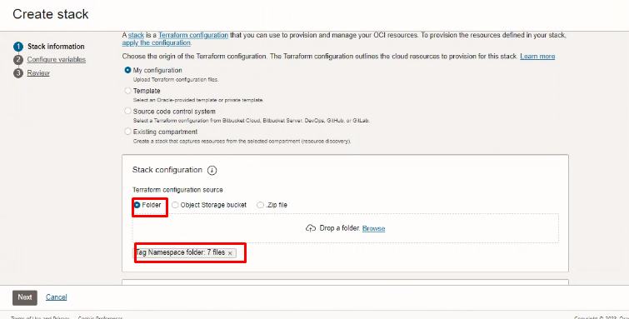

Select the parameters as per the below screen,
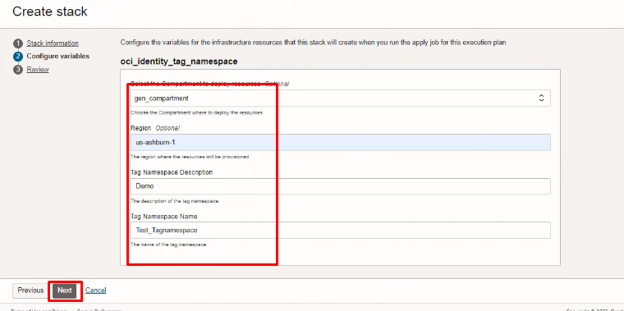
Click “NEXT”
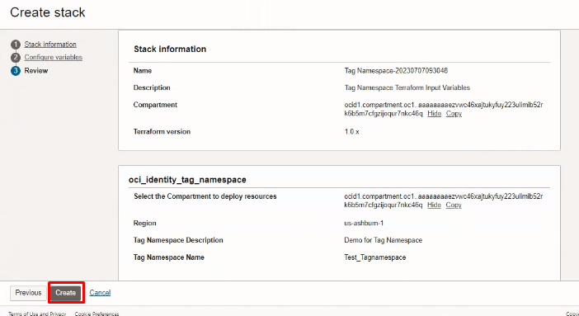
Click “CREATE”

Plan the Job

Click the “Plan”
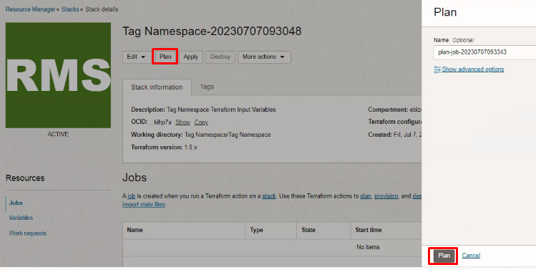

Verify the Plan is successful.
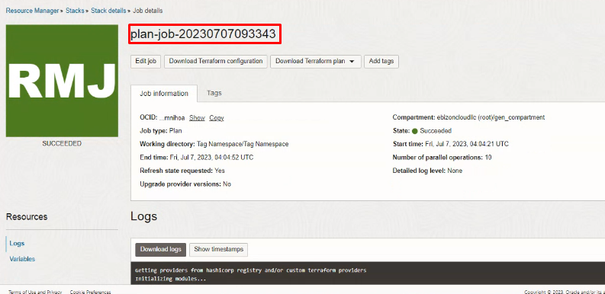
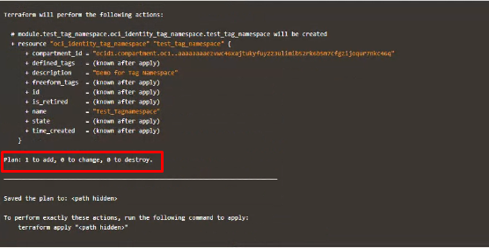

Apply the Job

Once the “plan” is success, now click “Apply”
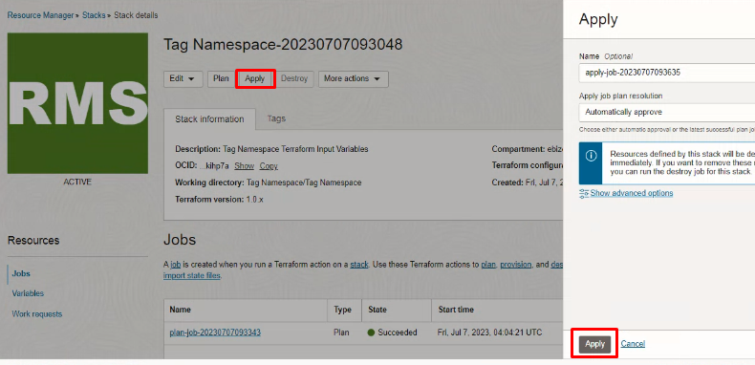
Verify the Apply is successful.

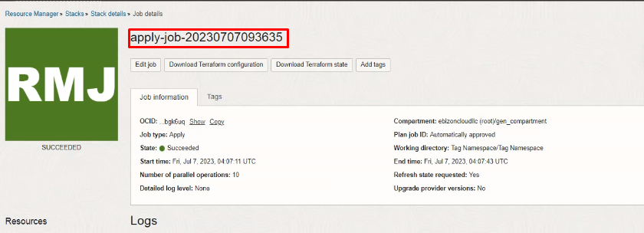

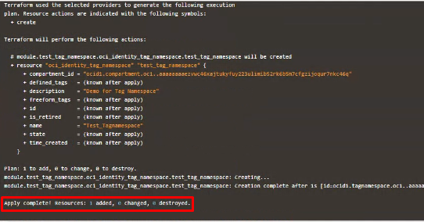

Verify in the Console

Go to OCI Console Governance & Administration Tenancy Management Tag Namespace
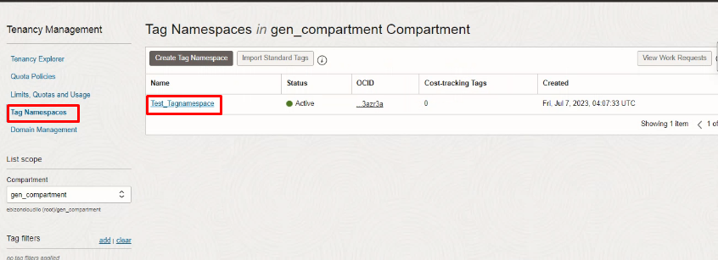

Tenancy Management Tag Namespace Tag Namespace Details

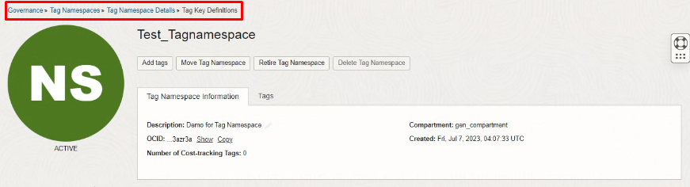

Destroy the stack

Create a destroy job in Resource Manager to release resources associated with a stack and clean up the tenancy. Once destroyed data cannot be recovered from resources.

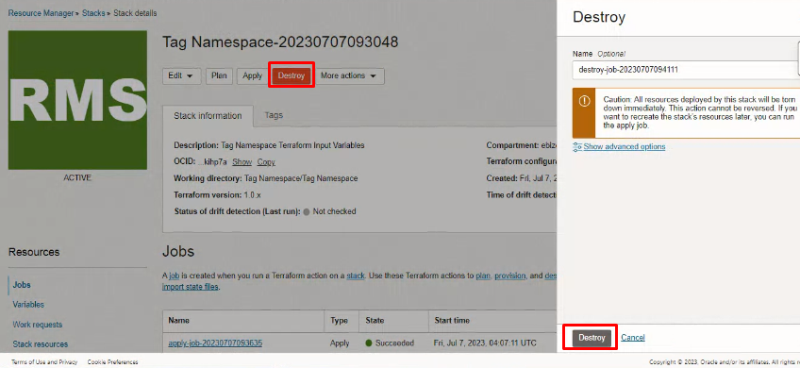

#END#

